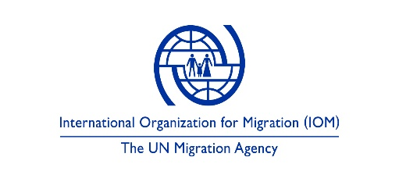

PROCUREMENT OF FUEL-EFFICIENT STOVES (FES)
Term of Reference
Background:
Decreased access to adequate quantities of cooking energy (Firewood, agricultural biomass etc.) within military perimeters (safe zones) in newly accessible areas in Borno state has led to increased risk of violent attacks on vulnerable Internally displaced persons who often go in search of available cooking energy. some cases of kidnapping and killings have been reported in recent times, women and children are the most predisposed due to the societal norms which saddled them with the sole responsibility of sourcing for coking energy. In view of this, the International Organization for Migration is set to procure and distribute fuel-efficient stoves to IDP/returnees in areas of return within Borno and Adamawa state.
The purpose of providing and distributing the Fuel-Efficient Stoves is to:
- provide low-income households with efficient cooking stove which will further limit firewood consumption and introduce the use of other biodegradable cooking energy such as briquettes.
- reduce risk of violent attacks on women in the community while in search of firewood and other cooking biomass.
- Provide women the opportunity to develop their skills with decreased time spent in search for firwood and other cooking energy.
- Limit deforestation/desert encroachment.

This document will serve as a guide to the prospective vendor on the specification of the fuel-efficient stove, the quantity, quality, and timeline for delivery upon issuing of purchase order.
Procurement Guide/Vendor Requirement
The following should be adhered to:
- Five thousand (5,000) pieces of Fuel-Efficient stoves will be supplied for onward distribution to 2,000 households in areas of return within Borno and Adamawa.
- Delivery should be made directly to IOM Warehouse Maiduguri
- Physical Samples of stove should be submitted along with Request for Quotation (RFQ) for quality check.
- The stove colour should be deep-blue or IOM-blue and branded with white write-up “Distributed by IOM with Funding from USAID - BHA” as in below.
Fuel-Efficient Stove
Distributed by IOM with Funding from USAID-BHA

Design/Write up will be made available
- The stove should be delivered in a plain brown carton as in below [sticked on the carton].
Fuel-Efficient Stove
Distributed by IOM with Funding from USAID-BHA

- Quality of stove should not be compromised during delivery, hence the zquality must be same as samples presented along with RFQ, otherwise supply will be rejected.
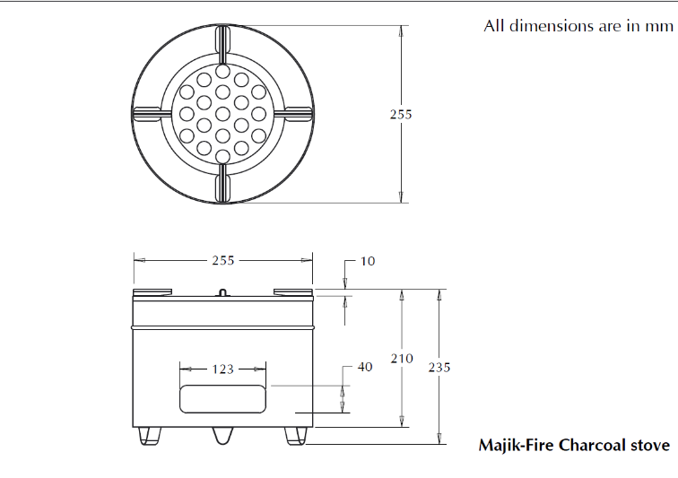
- Supply should be completed within one month of issuing Purchase Order.
Figure 1: Sketch of Fuel-Efficient Stoves

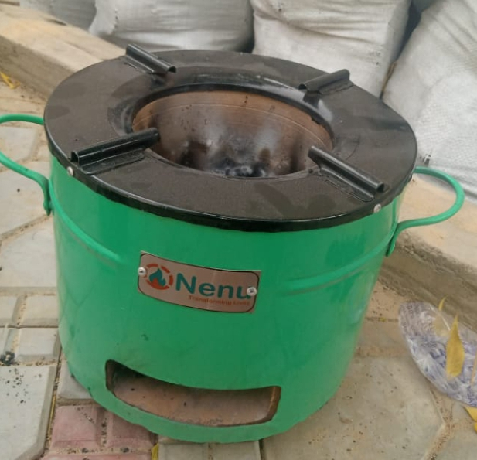
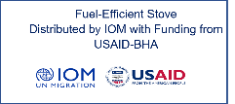
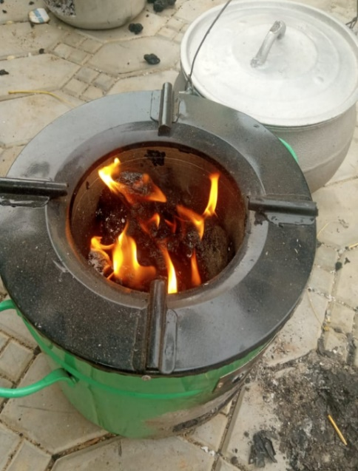
Figure 2: Picture of Fuel-Efficient Stoves. (Sample)

DECLARATION BY SELECTED COOPERATIVE/VENDOR
I ……………………………………………………………………of ……………………………………………….……. hereby declare that, I have read and understood the content/term for the supply of 2,000 Fuel-Efficient stoves and pledge to adhere strictly to the term.

Signature: Designation: Date:

